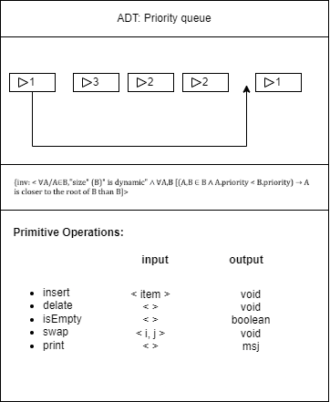

* Each element in the Binary Heap has a priority and a value, which are represented by the tuple ⟨priority, value⟩. This is represented by the statement ∀A/A" is an element of " B, A=⟨priority,value⟩.
* The Binary Heap is sorted by priority, meaning that elements with higher priority values are placed closer to the root of the heap. This is represented by the statement ∀A, B/A, B" are elements of " B, "If " A. priority<B.priority, " then " A" has higher priority than " B.

